**Acer Foco Font Installation Process   
(final version: 2.001)**  
  
1. Please unzip the attached file (AcerFoco.zip) using the password "Acer". Then, save the unzipped file onto your Desktop.   
*(See attached file: AcerFoco.zip)*   
  
2. Run AcerFOCO.exe.   
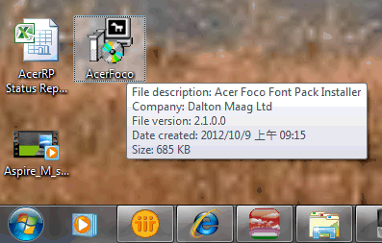  
  
3. The software will automatically install version 2.001 of the Acer Foco font.   
  
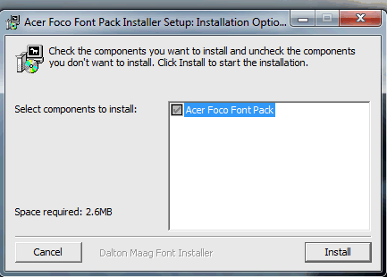  
  
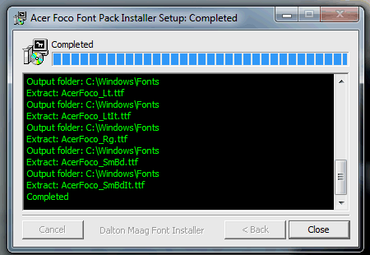  
  
  
4. Restart your PC to finish the Acer Foco font installation.  
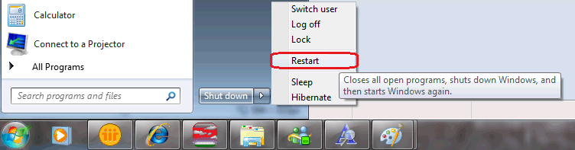  
  
5. After restarting your PC, go to C:\Windows\Fonts and find the Acer Foco file.  
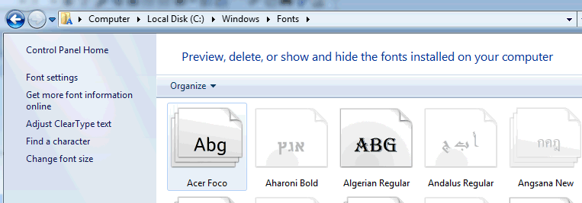  
  
6. Double-click on the Acer Foco file. There should be a total of 10 fonts in it. If you don't see 10 fonts, please repeat steps 2 - 4.  
  
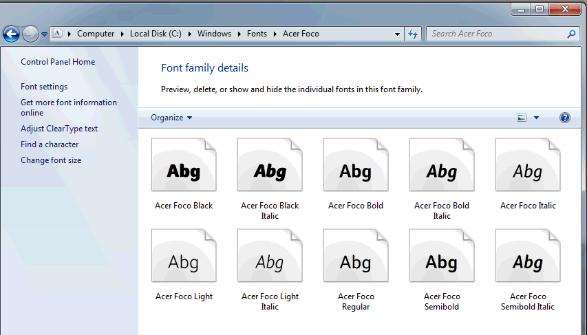  
  
7. Double-click on one of the font files to check the details.   
You can see the version information on the second line. It should show "Version 2.001". This means the font has been updated.  
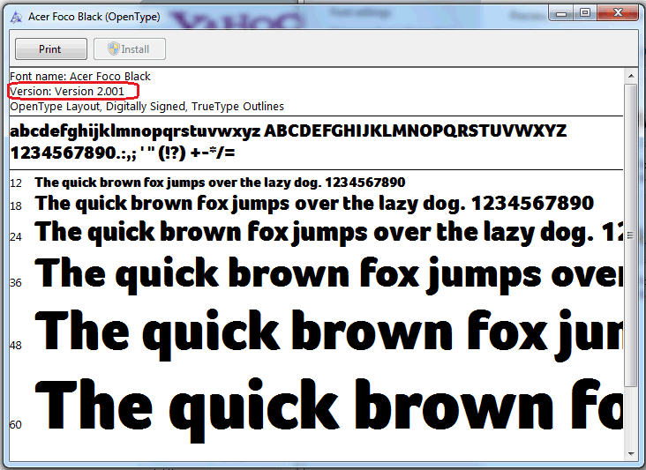  
  
8. Print a test page. If it prints correctly, then the font has been installed successfully.  
  
*(See attached file: Printer Test Acer FOCO font.docx)*  
  
9. If the test page doesn't print right, then please contact your MIS representative to help solve the issue.